Analysis from VAS for August

Alne road sign pointing into village i.e. car speeds leaving the village.
Key points
- 43,161 vehicles
- 85% of traffic is traveling 30.7mph or below.
- 98% of traffic is travelling below 34.8mph
- One recording at 50mph!
- If you look at the average speed of those above 30 it is around 33mph

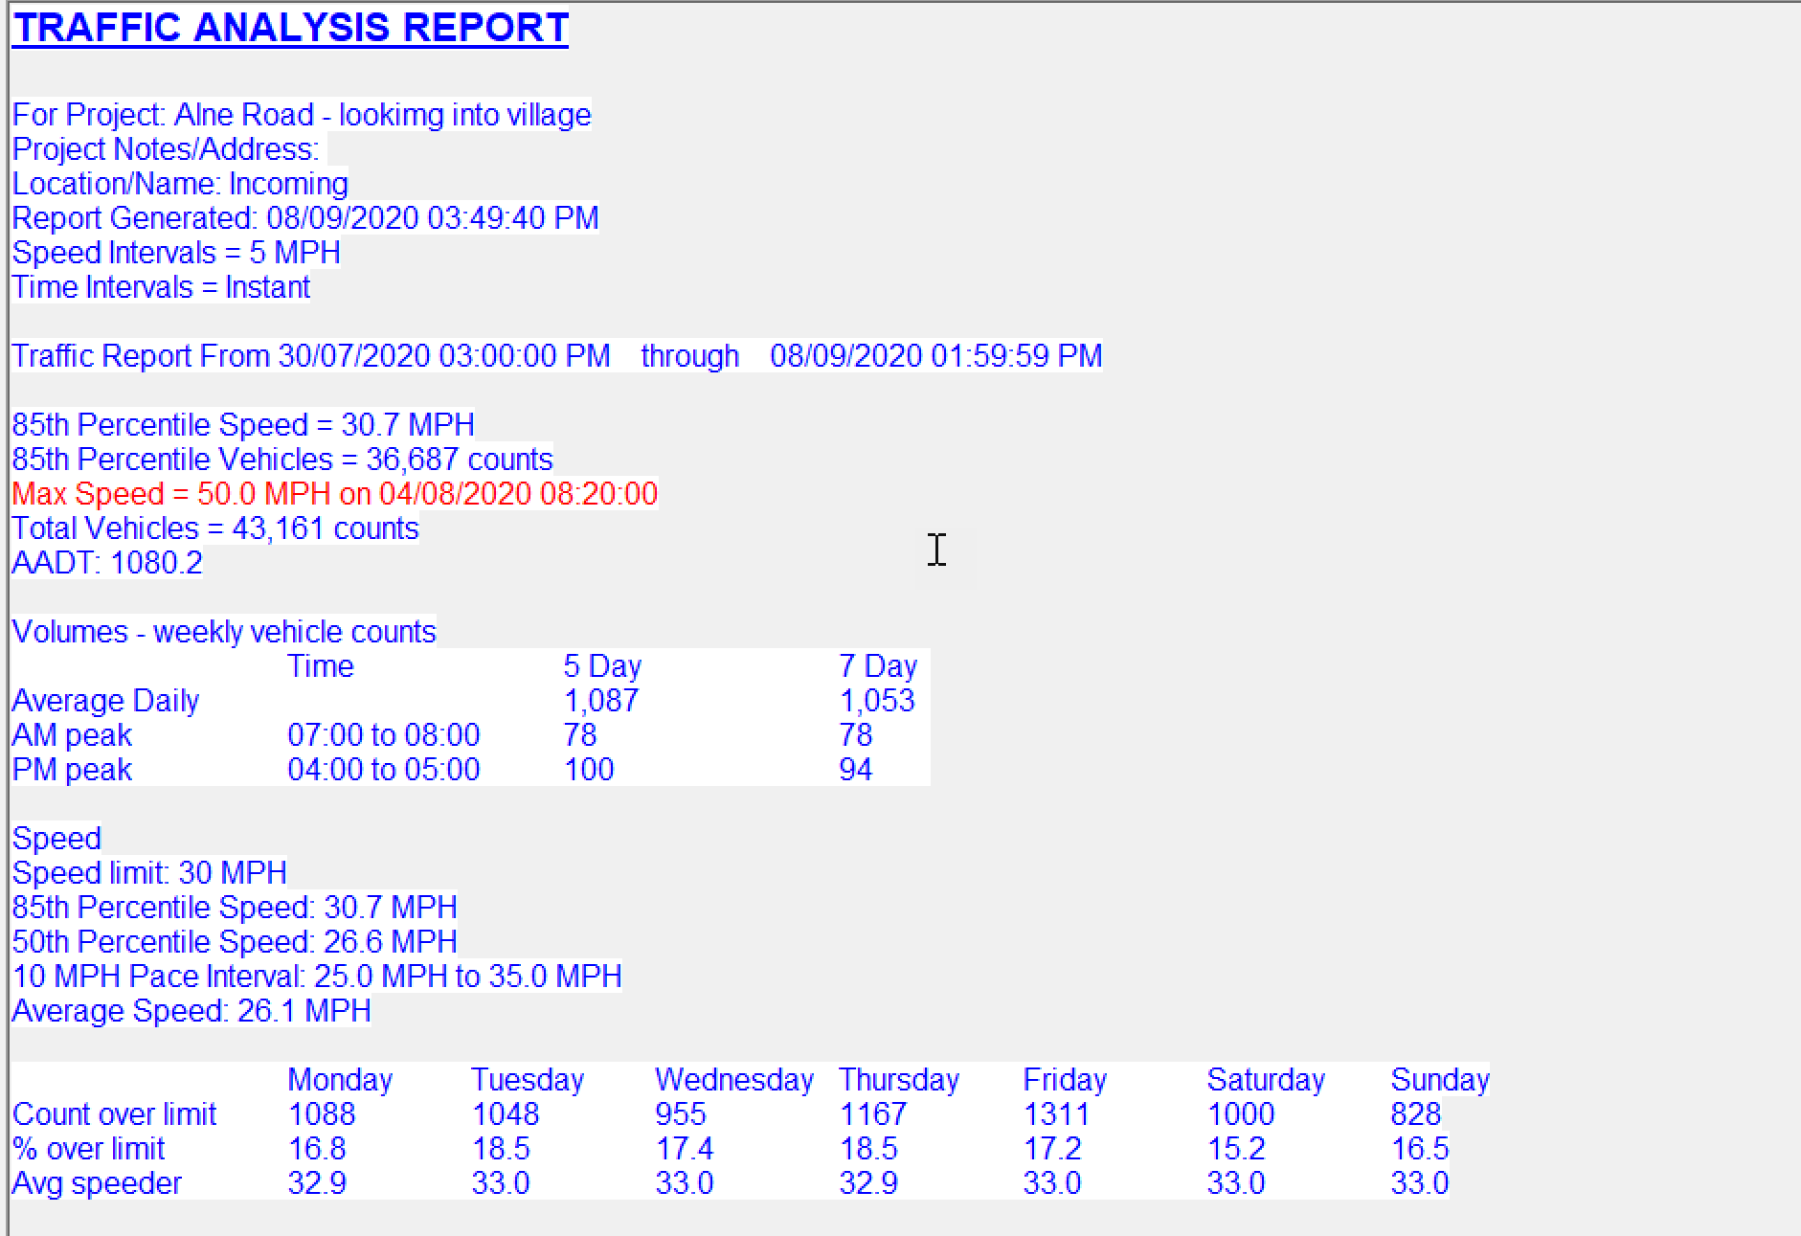

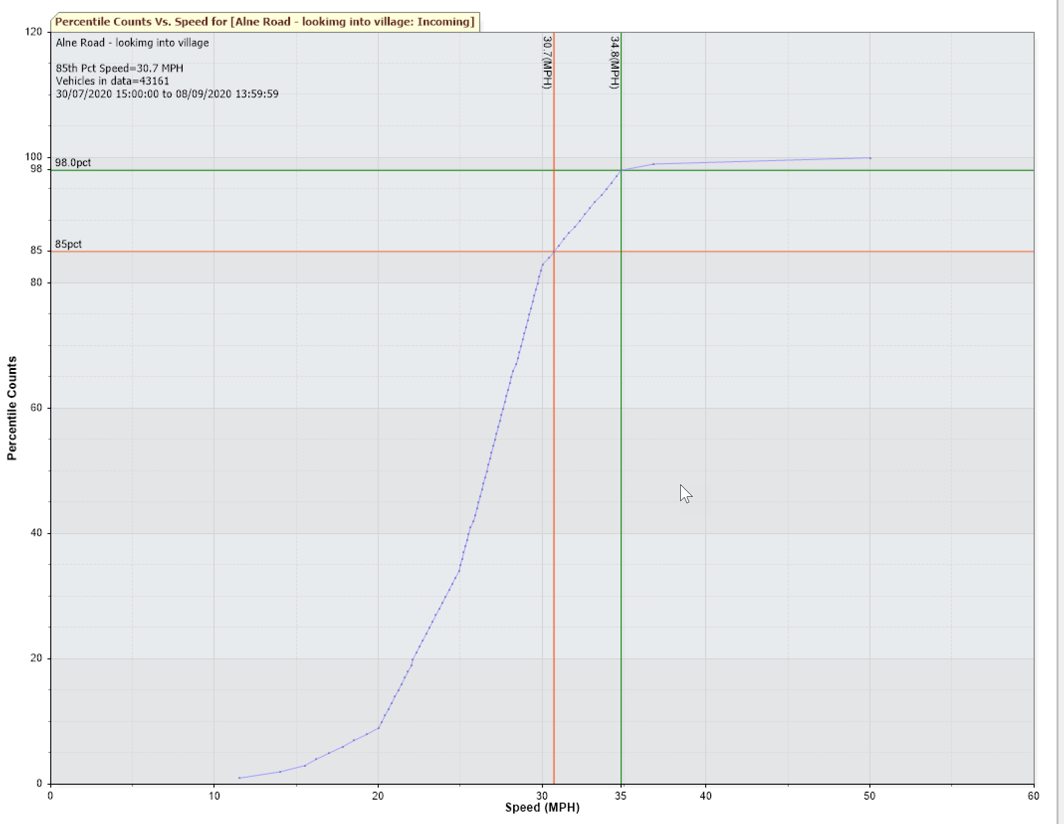

Newton Road sign
This sign catches the speed of vehicles before they enter the 30mph zone and so average speeds will be higher.
- 36,861 vehicles
- 85% of traffic is traveling 32.8mph or below.
- 98% of traffic is travelling below 39.4mph
- One recording at 65 mph!
- If you look at the average speed of those above 30 it is around 34mph

