Alne Road sign facing traffic leaving village
- 19,538 Vehicles
- 85% of traffic is traveling 30.1mph or below.
- 98% of traffic is travelling below 34.7mph
- One recording at 55mph
- If you look at the average speed of those above 30 it is around 33mph
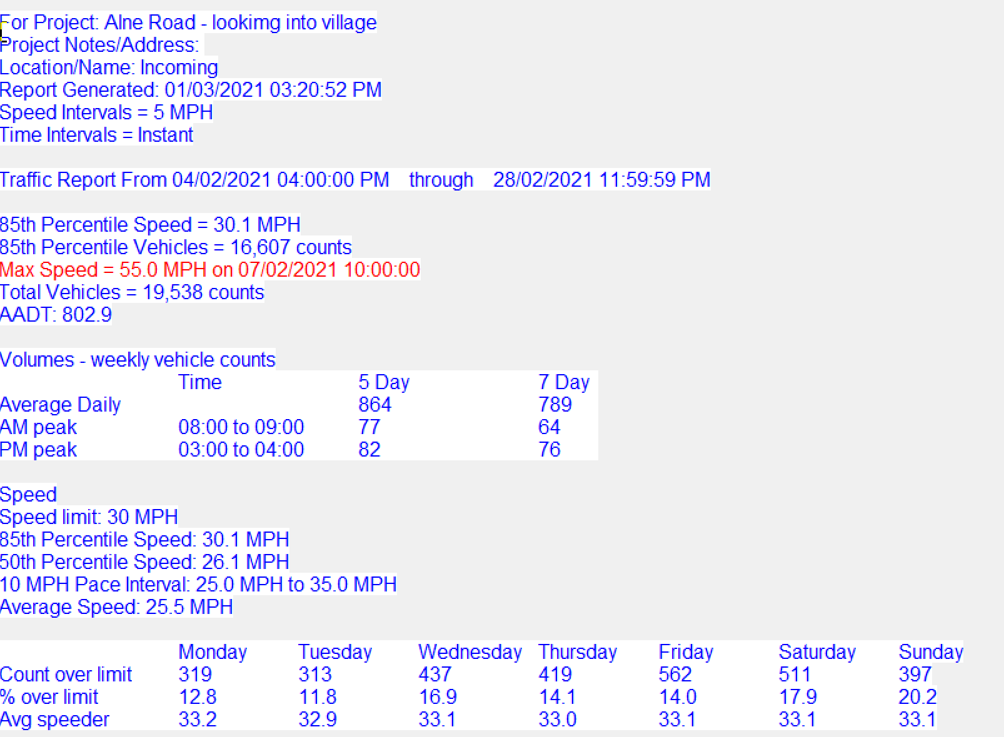

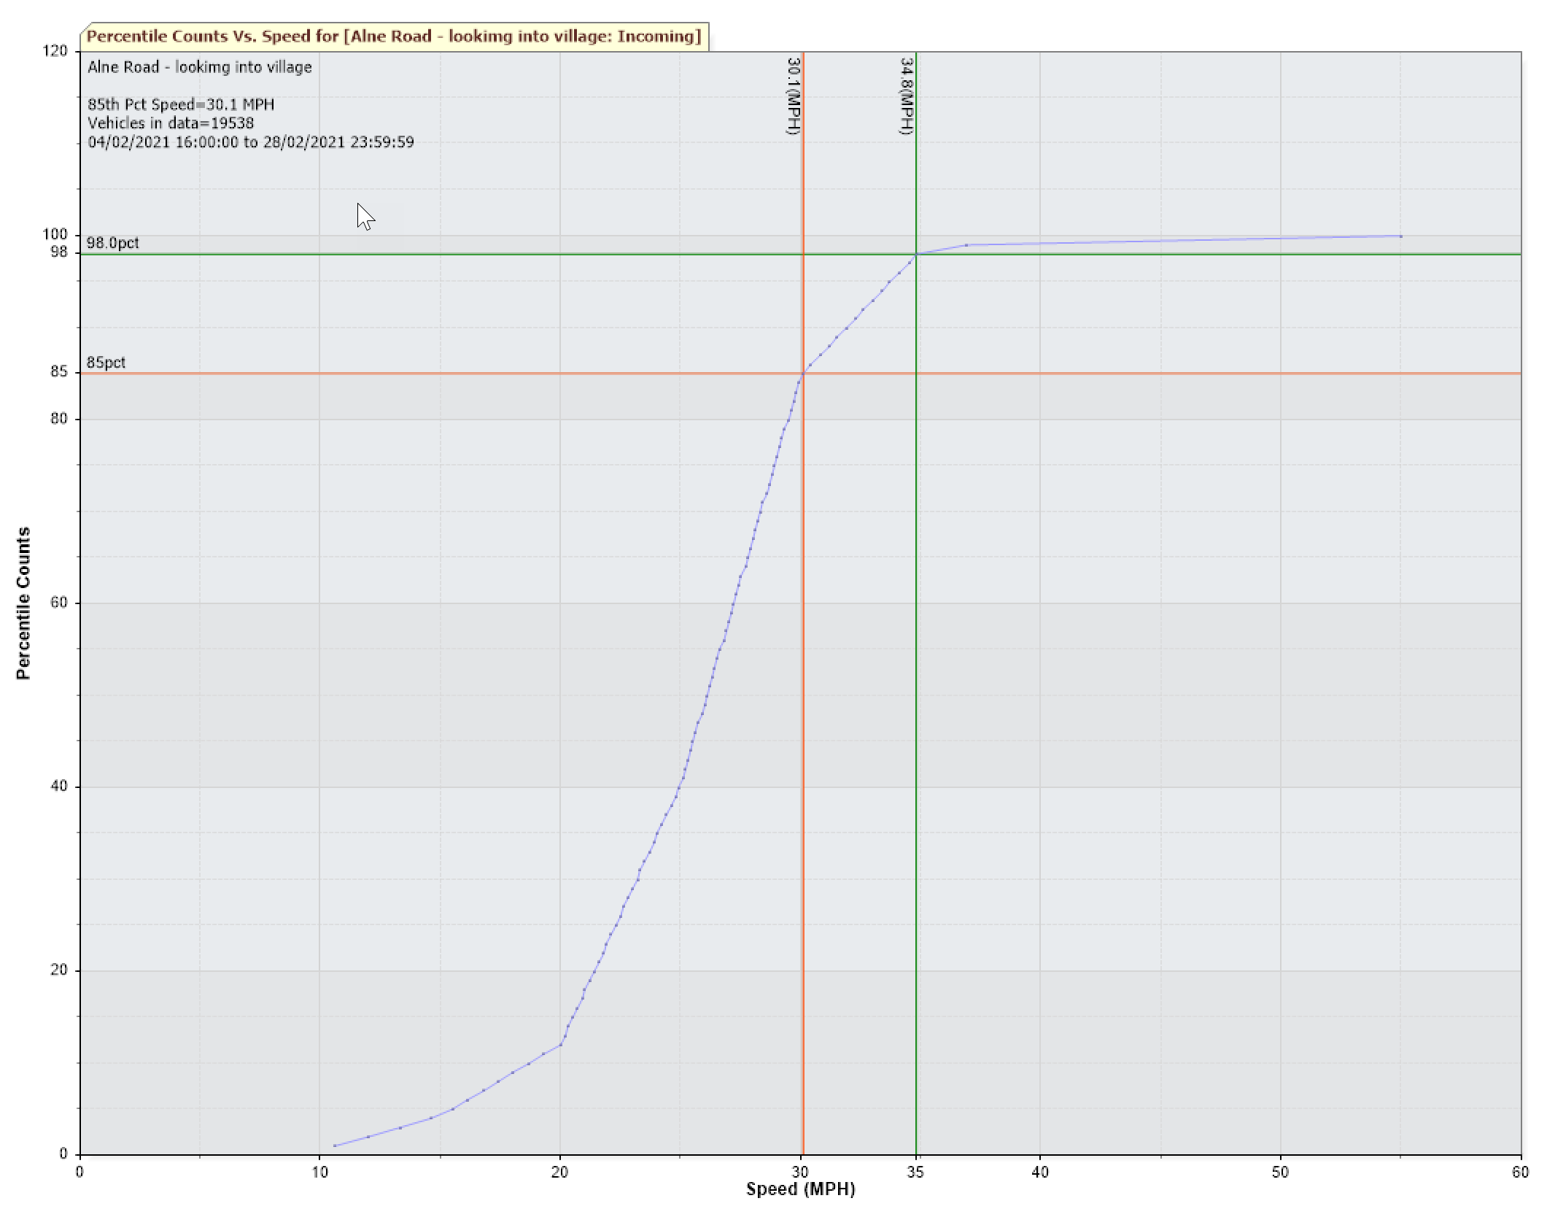

Newton Road Sign
22,227 Vehicles
85% of traffic travelling at 31.5mph or below
94% of traffic travelling at 35mph or below.
One speeder at 57mph.
Please note sign catches people just before the speed limit and so this influences the speeds seen.
Average speeder is around 34mph
