Alne Road sign facing traffic leaving village
- 62,386 vehicles – this is large increase on previous 27,000 ???
- 85% of traffic is traveling 29.8mph or below.
- 98% of traffic is travelling below 34.7mph
- One recording at 50mph
- If you look at the average speed of those above 30 it is around 33mph
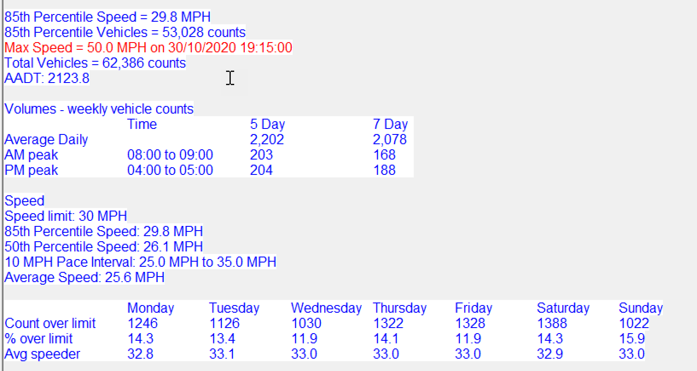

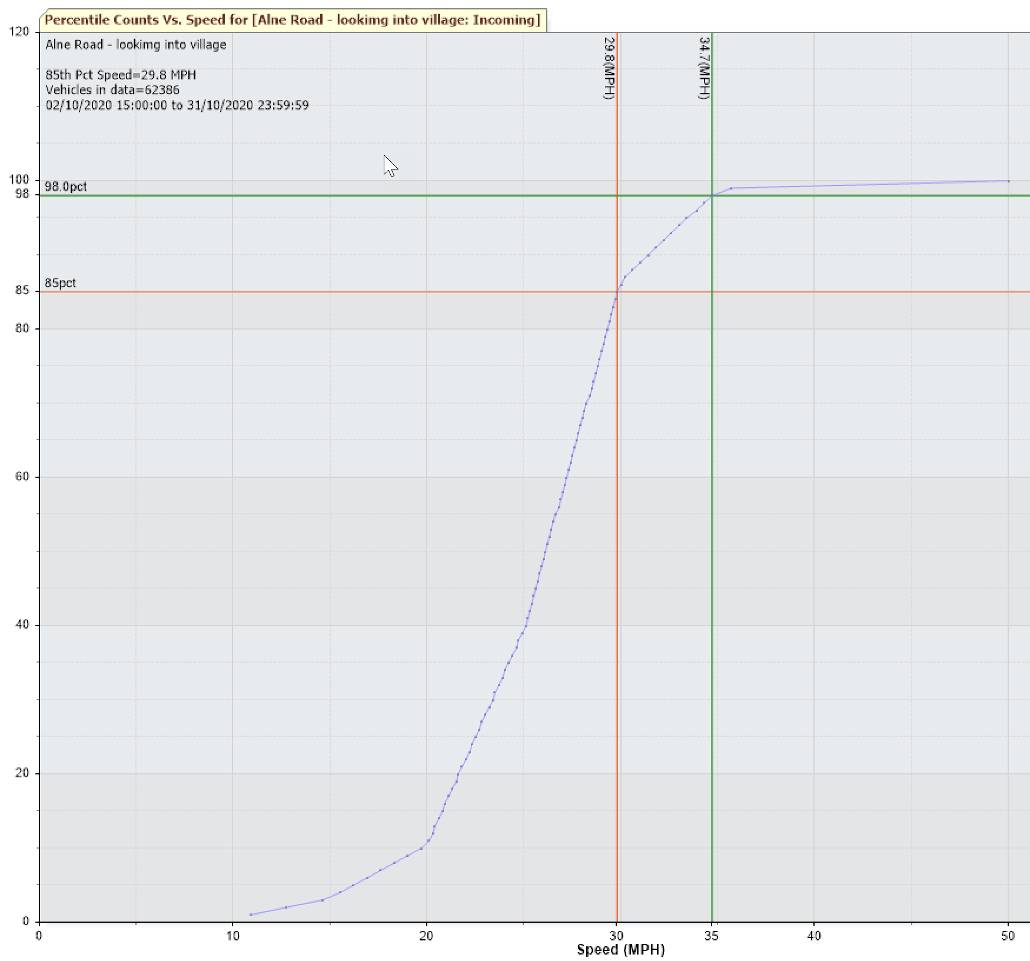

Newton Road Sign
No data this month due to problem with download.
I will try and retrieve again but suspect it will be gone.

